

COMSATS University Islamabad, Lahore Campus

QUIZ-2 – FALL 2024
Course Title: | Software Project Management |  |  |  |  | Course Code: |  | CSE494 |  | Credit Hours: | 3(2,1)
Course instructor/s: | Humaira Afzal |  |  |  | Program Name: |  |  | BS Software Engineering
Semester: | 7th | Batch: | FA21-BSE | Section: | B |  |  | Date: | 24-10-2024
Time Allowed: | 45 Minutes |  |  |  | Maximum Marks: |  |  |  | 20
Student’s Name: |  |  |  |  | Reg. No.

Question : [Marks:8+12=20]
CLO 2: Determine the project scope and cost estimation within a time frame for a software project.
Bloom Taxonomy Level: <Applying>

A software team is developing a comprehensive university management system to handle student enrollment, course registration, grading, and faculty management. During testing, it is discovered that the system’s reporting feature does not fully meet the user requirements outlined in the project scope. Faculty members are requesting enhanced reporting capabilities for course evaluations.

As the project manager, how would you apply scope validation and control techniques to address this issue while ensuring that the new reporting requirements are appropriately handled within the scope of the project? (Marks:08)

Based on the above case study, the activities, their duration and dependencies are given below:

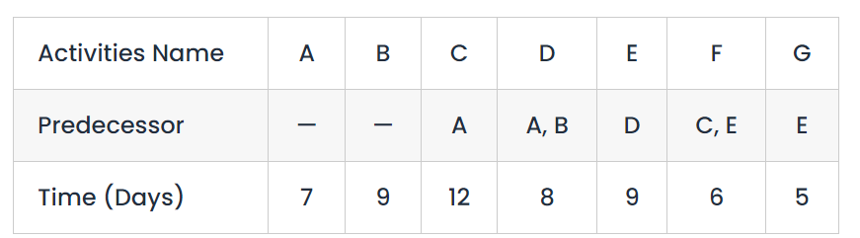

- Create a Network Diagram (6 Marks)

Draw an activity-on-node (AoN) network diagram for this project, using a standard node convention to display the duration.

- Identify the Critical Path (4 Marks):

Analyze the network diagram and determine the critical path for the project.
- Apply forward and backward passes.
- Calculate Float.

- Determine the Project Duration (2 Marks):

What is the overall duration of the project based on the critical path?

Solution

Question : [Marks:8+12=20]
CLO 2: Determine the project scope and cost estimation within a time frame for a software project.
Bloom Taxonomy Level: <Applying>

Consider the following case study and answers the questions given at the end of this case study

A software team is developing a comprehensive university management system to handle student enrollment, course registration, grading, and faculty management. During testing, it is discovered that the system’s reporting feature does not fully meet the user requirements outlined in the project scope. Faculty members are requesting enhanced reporting capabilities for course evaluations.

As the project manager, how would you apply scope validation and control techniques to address this issue while ensuring that the new reporting requirements are appropriately handled within the scope of the project? (Marks:08)

Solution:

To address the new reporting requirements, the following scope management techniques would be applied:

1. Scope Validation: First, review the original requirements documents and the scope statement to confirm what reporting features were agreed upon. Conduct a formal review with the stakeholders (faculty members) to understand how the current functionality falls short of expectations.

2. Gap Analysis: Perform a gap analysis to identify the specific differences between the current reporting feature and what the faculty needs for course evaluations.

3. Change Request Process: If the new requirements are considered an enhancement, initiate a formal change request. Assess the impact of adding these features on the project’s scope, schedule, and cost.

4. Prioritize the New Requirements: Work with university stakeholders to prioritize the enhanced reporting capabilities. Determine if these changes can be deferred to a later phase of the project or need to be addressed in the current phase.

5. Impact Assessment and Approvals: Conduct a detailed impact assessment for incorporating the new reporting features, considering the development and testing efforts required. Obtain formal approval from both internal stakeholders and university administration.

6. Update the Scope Statement and Project Plan: If the new reporting features are approved, update the project scope and adjust the work breakdown structure (WBS) to include the enhanced reporting.

7. Communicate and Implement: Once approved, communicate the changes to the development team and update all relevant project documentation.

Based on the above case study, the activities, their duration and dependencies are given below:



- Create a Network Diagram (6 Marks)

Draw an activity-on-node or activity on arrow network diagram for this project, using a standard node convention to display the duration.

- Identify the Critical Path (4 Marks):

Analyze the network diagram and determine the critical path for the project.
- Apply forward and backward passes.
- Calculate Float.

- Determine the Project Duration (2 Marks):

What is the overall duration of the project based on the critical path?

Solution:

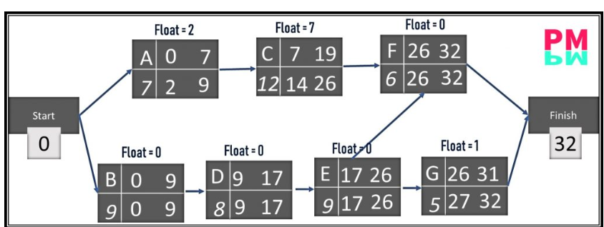

Critical Path :

B – D – E –F

Project Duration:

9+8+9+6 =32

